Reddit Alien Pattern
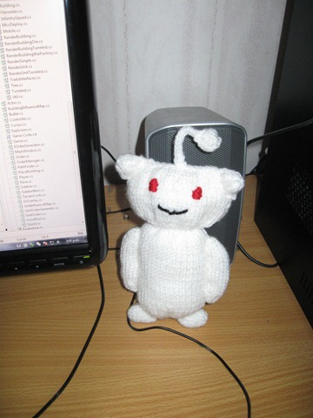
Body and Head
Cast On 16 stitches
Purl 1 row
(Knit1, knit front and back of same stitch) along row (24 stitches)
P 1 row
(K1 Kfb) along row (36sts)
Stst 26 rows

(K1 k2tog) along row (24sts)
P
(K1 Kfb) along row (36sts)
P
(K1 Kfb) along row (54sts)
P
Stst 10 rows
(K1 K2tog) along (36)
P
(K1 K2tog) along (24)
Bind off purlwise

Sew up CO edge and half way down body, (seam will be along side of body). Sew up BO edge and down body leaving a gap to stuff. Stuff then sew up hole.
Embroider face.

Ears (make 2)
CO12
P
(K1 K2tog) along (8sts)
P
(K1 K2tog) to last 2 st, k, k. (6)
P

Pull thread through stitches tightly and sew up. I added a little bit of stuffing and then attached them to the head along CO edge

Arms (make 2)
CO 10
Stst 19 rows

Pull thread though sts tightly and sew up seam. Stuff and pull up tight CO sts.
Attach to body

Feet (make 2)
CO 10 sts
Stst 6 rows
Pull thread though sts sew up seam and stuff . Pull CO edge up tightly and attach to body.

Bobble
I used an I-cord and used a pipe cleaner to make it stand up.
The ball end-
CO 9
Beg w P row stst 5 rows
Pull thread through sts tightly, sew up seam, stuff and pull co edge up tightly.
Attach to I-cord.

